Module 5 Lab 1

Brandon Trinkle

IFT 458: Middleware Prog & Database Sec

Professor: Dinesh Sthapit

Mar 15, 2025

Module 5 Lab 1
- Screenshots of the installed Git and VSCode on your system.
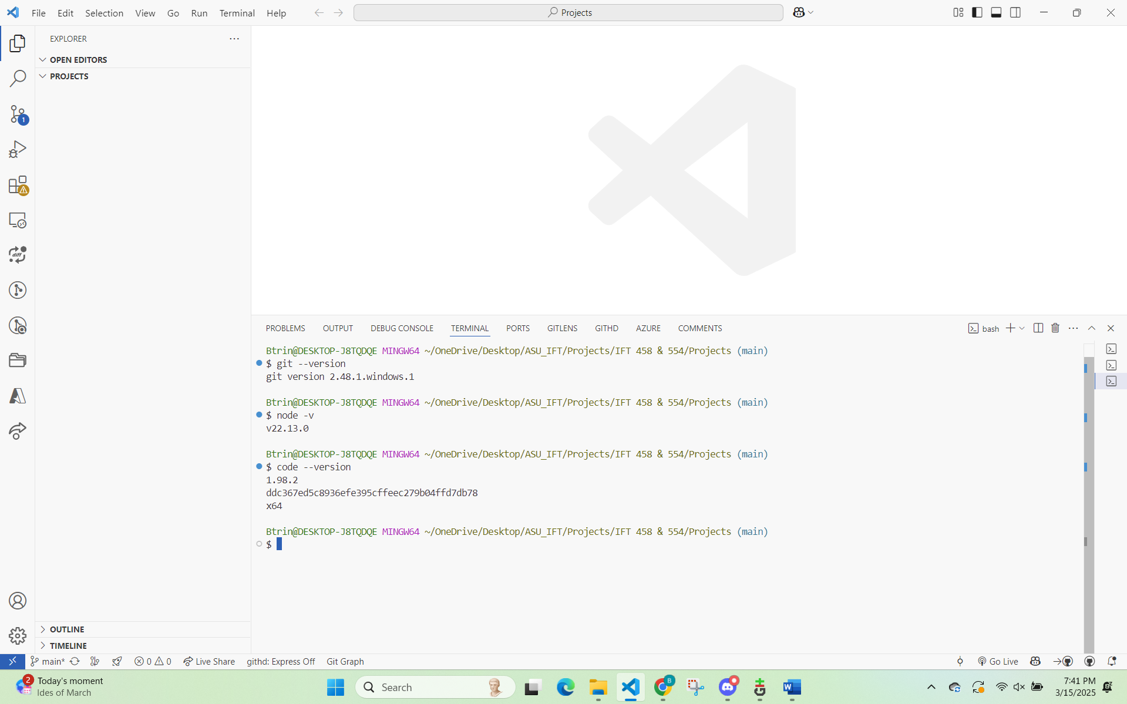

- Terminal showing the successful cloning of the repository and creation of a new branch.
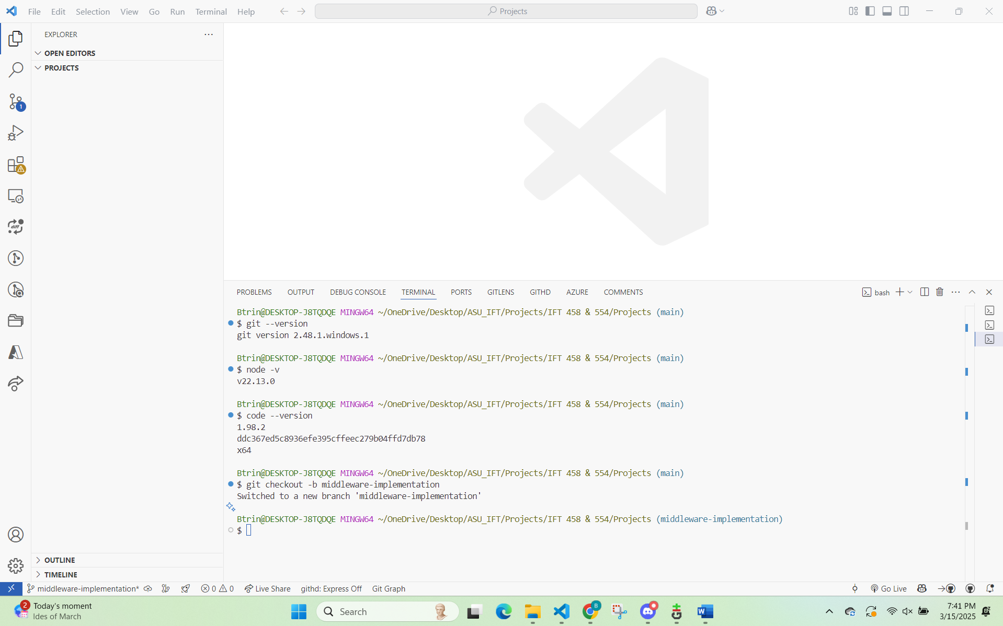

- Code snippets showing the middleware function and its integration into the server file.
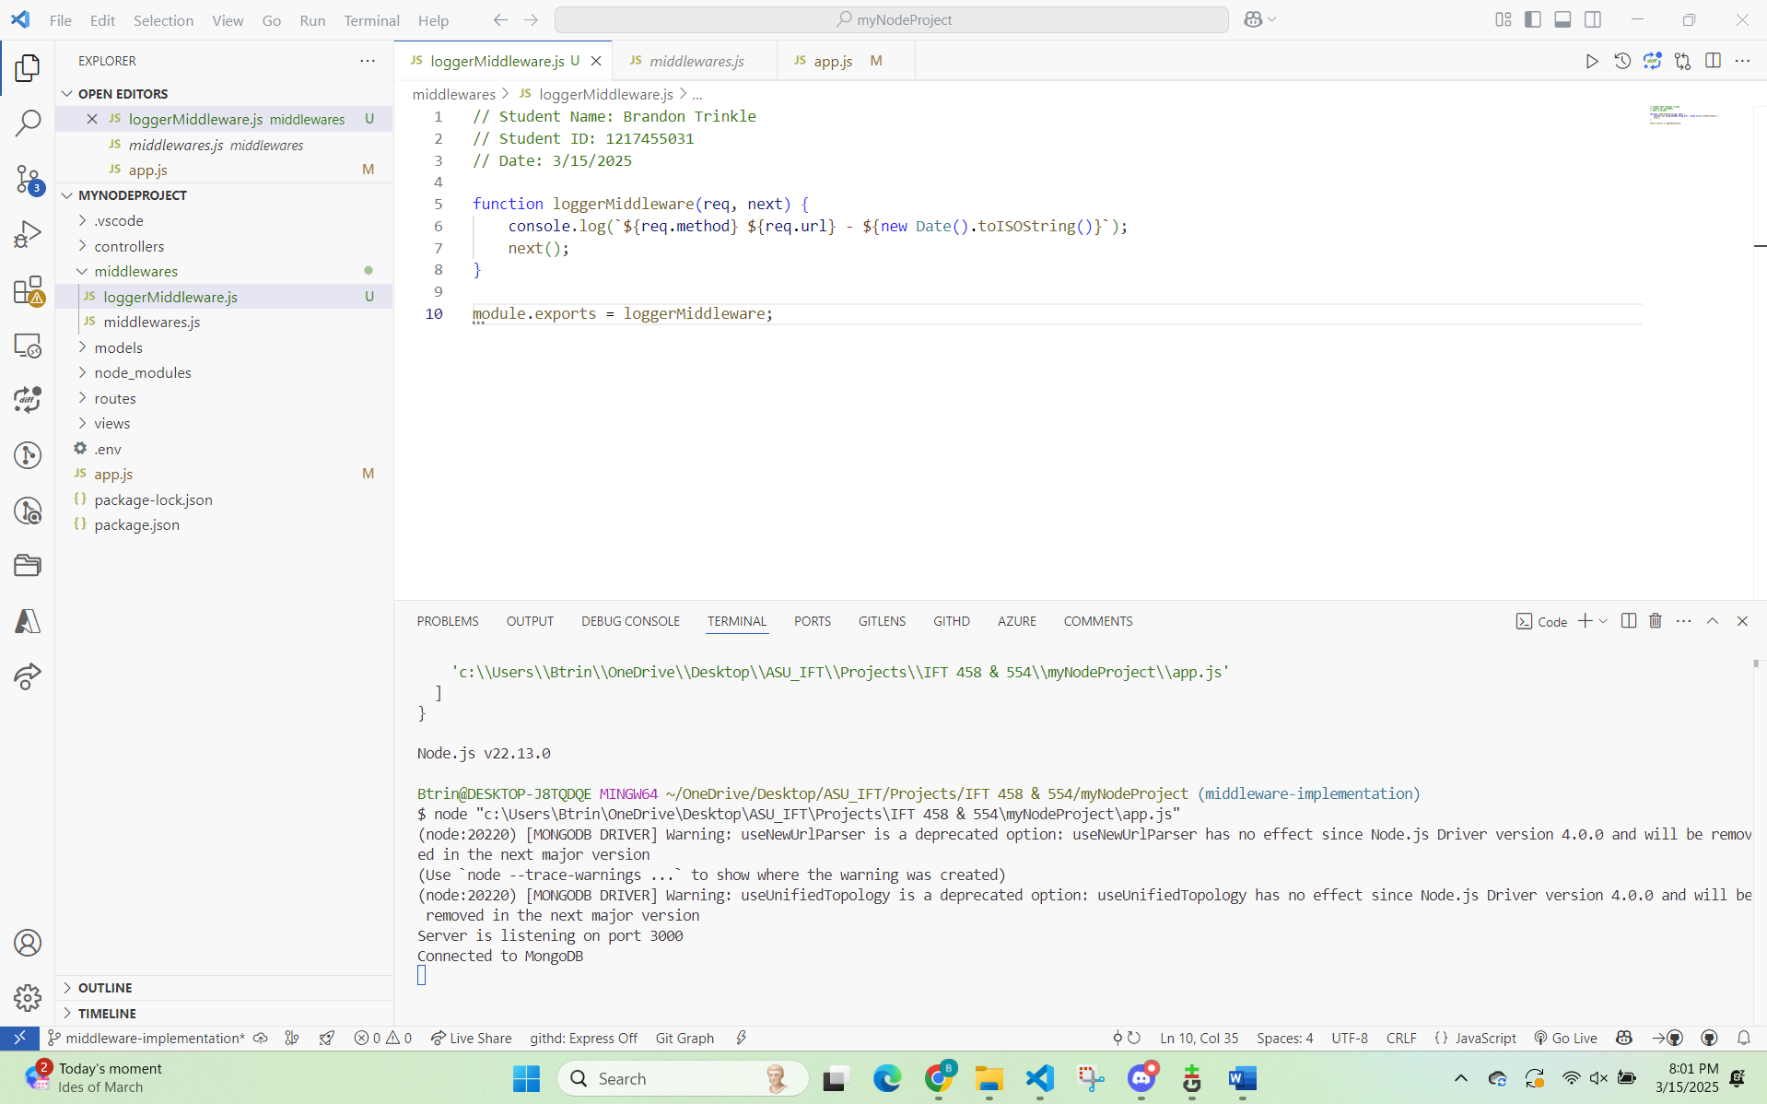
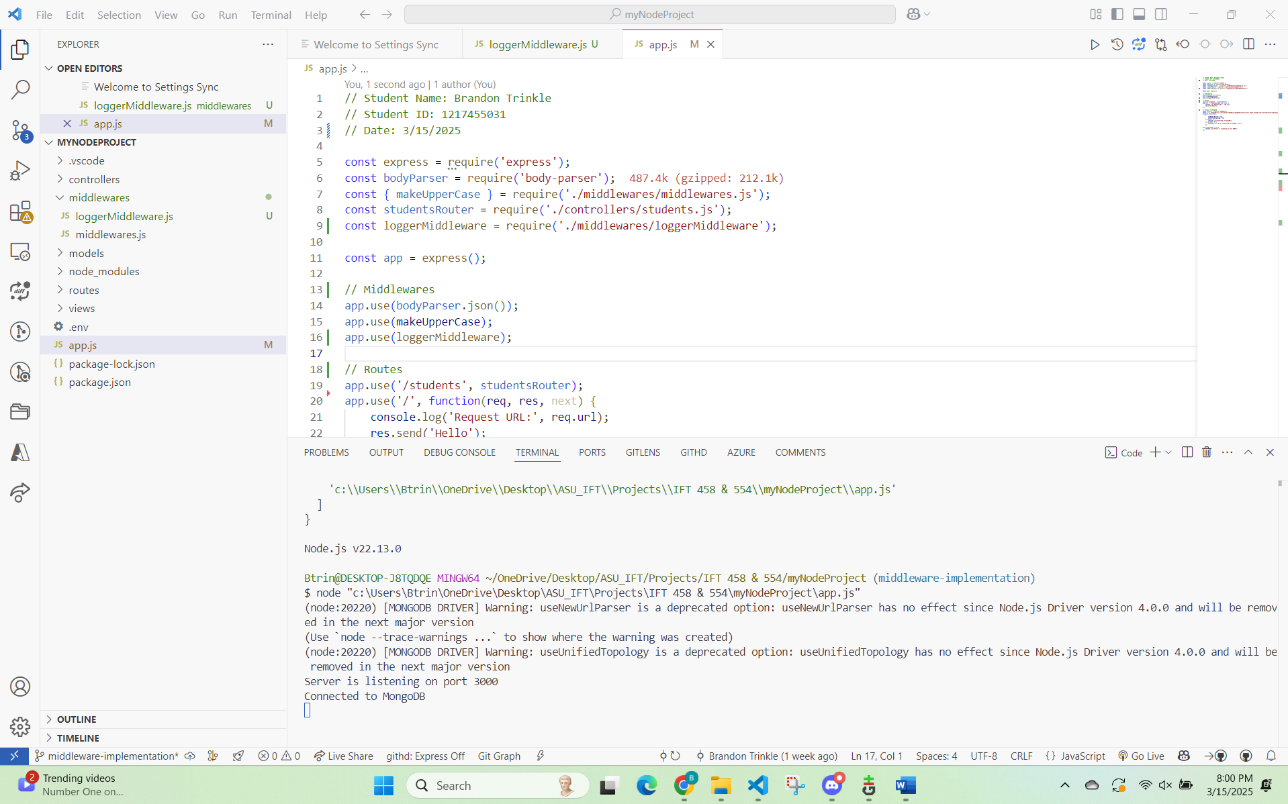

- Source control panel in VSCode showing staged changes and the commit message.
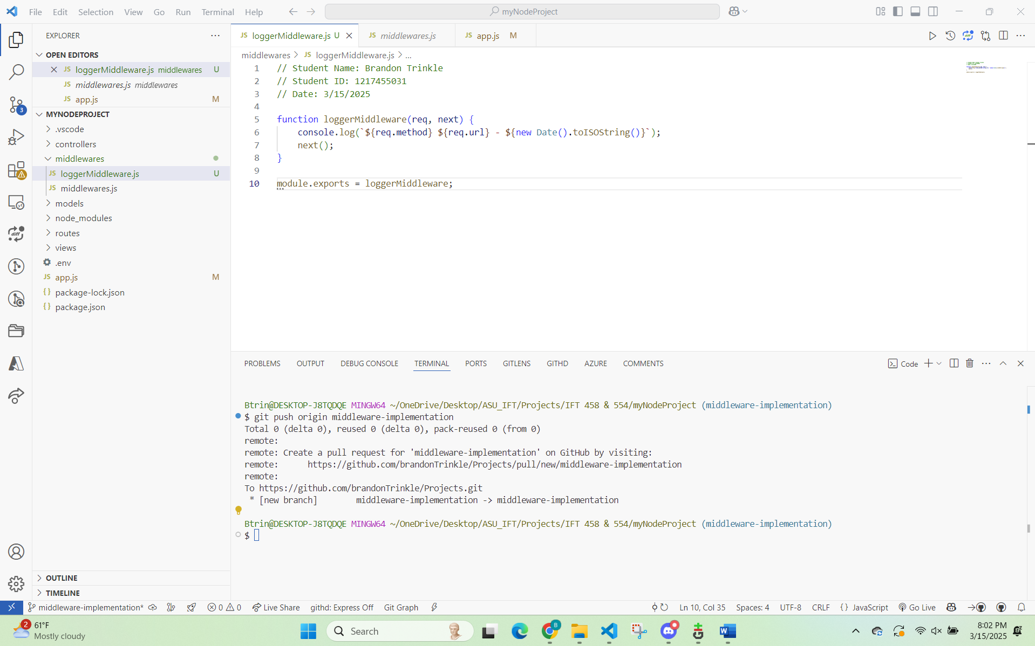

- Terminal showing the successful git push command.


- GitHub webpage showing the opened pull request.
